MPH Field Training Guide
for Sites and Supervisors

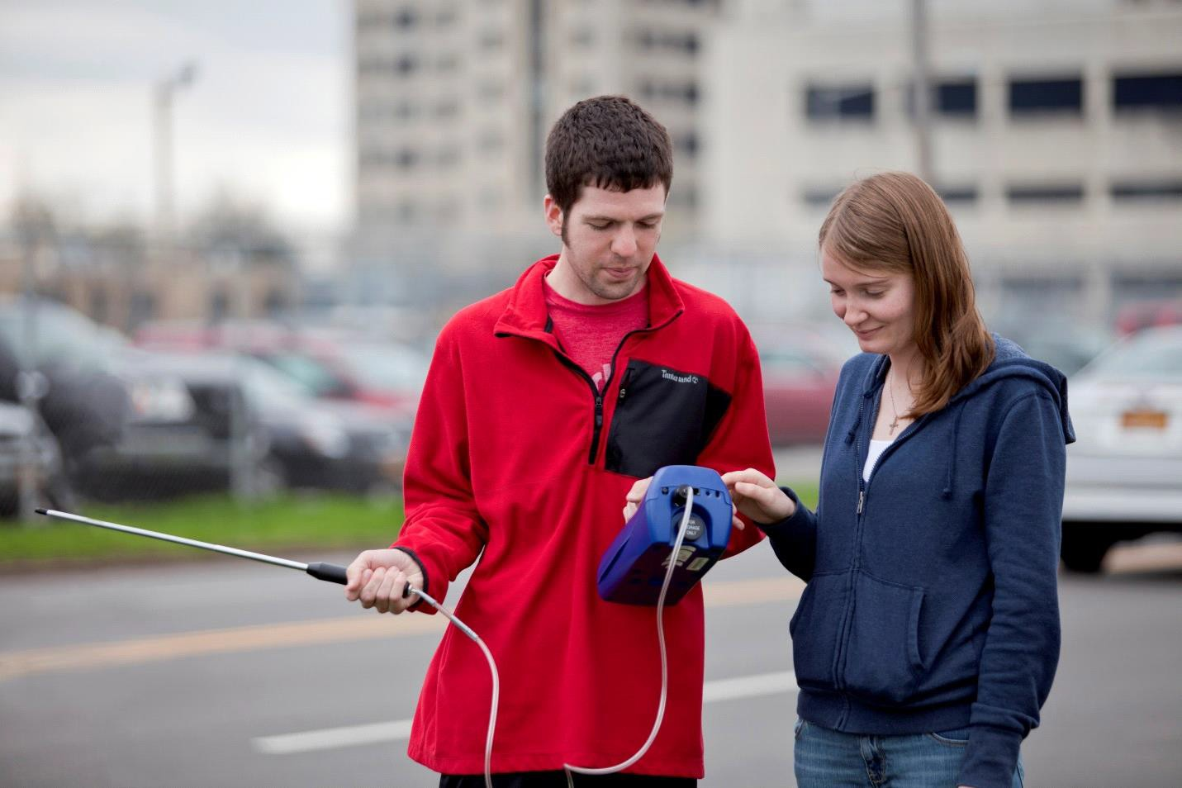
Photo credits: University at Buffalo School of Public Health and Health Professions/Suman Sarker

February 2019

Dean's Welcome Message to Site Supervisors
On behalf of the School of Public Health and Health Professions, I would like to thank you for supporting our Master of Public Health program by supervising our students in their field training experience. Site supervisors play a key role in assisting, advising, training and evaluating students throughout their field experiences. We know from our students that such experiences are viewed as a crucial element of their education. We also know that supervising a student is a commitment in time and effort, and we appreciate your willingness to share your expertise and knowledge to help train our students as future public health professionals. This opportunity is transformative for so many of our students. We’ve heard from many supervisors of our MPH students that they make significant contributions to the work of their agency, as well. We anticipate that you will find value in having our MPH students contribute to achieving your organization’s goals.
We aim to make this experience a valuable one for you, your organization and our students, and look forward to strengthening our partnership during and following the field training experience.
Thank you, again. With your support as a supervisor, our Master of Public Health students will gain invaluable knowledge, skills and experience in public health practice that they can take with them in their future careers.

Sincerely,

Jean Wactawski-Wende, PhD
Dean, School of Public Health and Health Professions
State University of New York at Buffalo

Field Training Overview

Field training is a cornerstone of the Master of Public Health (MPH) Program, providing students with diverse public health experiences vital to their professional growth. Students gain valuable hands-on learning opportunities unavailable in a classroom setting. The purpose of field training is for students to demonstrate public health competencies, through knowledge and skills acquired during the academic portion of their program, in a practical setting under an agency’s supervision and guidance. Field training is primarily a learning experience for the student, but it should also benefit the field training site.

UB’s MPH Program provides students with a well-rounded, broad-based public health education enabling them to work in many settings and program areas including:
- Advocacy
- Community organization, outreach and engagement
- Clinical practice transformation
- Data collection, statistical analysis and summarization
- Development of educational materials
- Epidemiological investigations, studies and research
- Health education and training
- Healthcare access and equity
- Health informatics/electronic medical records
- Literature review
- Meeting facilitation and coordination
- Need assessments
- Patient education
- Policy research and analysis
- Population-based study design
- Program development, implementation and evaluation
- Public speaking
- Quality improvement/quality control
- Research

Click here for additional information regarding the MPH Field Training Program can be found at the following link.

Field Training Objectives

The general objectives of field training are to:
- Provide students with the experience of working in a public health setting.
- Provide a learning experience whereby students become more skilled in particular competencies.
- Have students involved in projects or activities that provide a benefit to the mission and work of the field site.
- Help the student envision their own career path and gain insight into the types of employment opportunities available in public health.
- Identify a topic to be investigated in more detail in the MPH integrative project.
- Expand a student’s network of public health practitioners for future career opportunities.

Site Supervisor Criteria

The minimal criterion for a site supervisor is that they possess at least one year of relevant work experience or adequate formal education as determined by the MPH assistant training director.

Site Supervisor Responsibilities

To the extent feasible and appropriate, site supervisors will:
- Provide student with onsite supervision and support.
- Provide an overview of the public health program/setting of the field training site (could include, for example, an organizational chart; program goals, objectives, and activities; methods of surveillance; target population; copies of routine reports; and copies of ongoing research studies).
- Explain work rules and procedures, make resources available, and assist in establishing access to the various data systems that might be used by the student.
- Identify specific projects and/or activities for the student to complete.
- Provide confidentiality training to the student, reinforcing the importance of adhering to confidentiality requirements and the need for students to ‘de-identify’ or remove all information that could be used to identify an individual when discussing or documenting field training. If a field training site has specific policies related to protected health information and confidentiality, we anticipate that students will be trained in these policies at the field training site.
- Regularly meet with the student to provide teaching, constructive feedback and other guidance.
- Introduce student to colleagues and agency executives when possible.
- Provide student with opportunity to participate in and/or observe interprofessional collaboration activities when possible.
- Include student in internal and external meetings as appropriate.
- Allow student to shadow supervisor when appropriate.
- Provide readings/articles and resources helpful to student.
- If required, establish a funding mechanism for travel and other expenses.
- If required, provide secretarial support.
- Evaluate student performance at the conclusion of the field training experience.

Field Training Hours

Students must complete 120 hours of field training in a semester, but may choose to complete up to 240 hours of field training. There is no prescribed field training schedule as long as the required hours are completed. It may be useful to schedule students regularly, such as 10 or 20 hours per week. There is no expectation of student compensation for their field training experience.

Required Documentation

There are three electronic field training forms and a PowerPoint slide set that students are required to complete. Note: It is the student’s responsibility to ensure that all forms are completed and submitted.

Electronic field training forms are submitted via Time2Track’s MyInternshipJournal.com.

Students are required to complete the following field training forms

- Form 1 - MPH Field Training Description – Completed by student and then forwarded to their site supervisor for review prior to the start of the internship. Once signed by the supervisor, the form is routed to the faculty advisor for review/signature.
- Form 2 - Evaluation of Student's Performance – Forwarded by student to their site supervisor at the conclusion of the internship. Once completed by the supervisor, the form is routed to the student and then to the faculty advisor for signatures.
- Form 3 - Student's Evaluation of their Field Training Experience - Completed by student at the conclusion of the internship. Once completed by the student, the form is routed to the faculty advisor for signature.

PowerPoint Slide Set

The PowerPoint slide set is submitted to the faculty advisor after completion of the field training experience.

Interprofessional Education and Collaboration

The University at Buffalo has a strong commitment to interprofessional education and collaboration. Interprofessional education cultivates a teamwork approach to the delivery of healthcare. The goal of interprofessional education is to provide students with the knowledge, skills, attitudes and framework necessary for them to practice effective patient centered healthcare in a collaborative manner with other healthcare related disciplines.
Interprofessional collaboration occurs when healthcare providers from different disciplines work together with patients, families, caregivers and communities to deliver the highest quality of care. This inclusive, multifaceted approach makes primary care the responsibility of teams of healthcare professionals rather than a single healthcare provider. Effective collaboration among healthcare providers has the potential to profoundly improve the quality of patient care.
Field training can play a significant role in a student’s career development in this area by providing them with an opportunity to serve as a member of an interprofessional team or working collaboratively with physicians, nurses, counselors, pharmacists, attorneys or other professionals at the site, enabling them to apply knowledge and skills gained in the classroom to real-life situations and experiences.

Protected Health Information and Confidentiality

Throughout students’ field training, and especially when completing forms and reports, they need to be mindful of the confidential information—including patients’ personal health information (PHI)—that they have access to at field training sites. A site supervisor should remind students that whenever they discuss or document field training, they need to ‘de-identify’ or remove all elements that could be used to identify an individual. If a field training site has specific policies related to protected health information and confidentiality, we anticipate that students will be trained in these policies at the field training site. Learn more about confidentiality and PHI as outlined in the contract with all affiliated field training sites.

MPH Competencies

Competencies describe activities or behaviors students should be able to demonstrate, to an appropriate extent, upon completion of a learning experience. Competencies acquired during field training vary depending upon the particular circumstances and opportunities offered by the site and the student’s concentration. A single field training experience is not expected to address all competencies.

Click here for foundational and concentration specific competencies.

