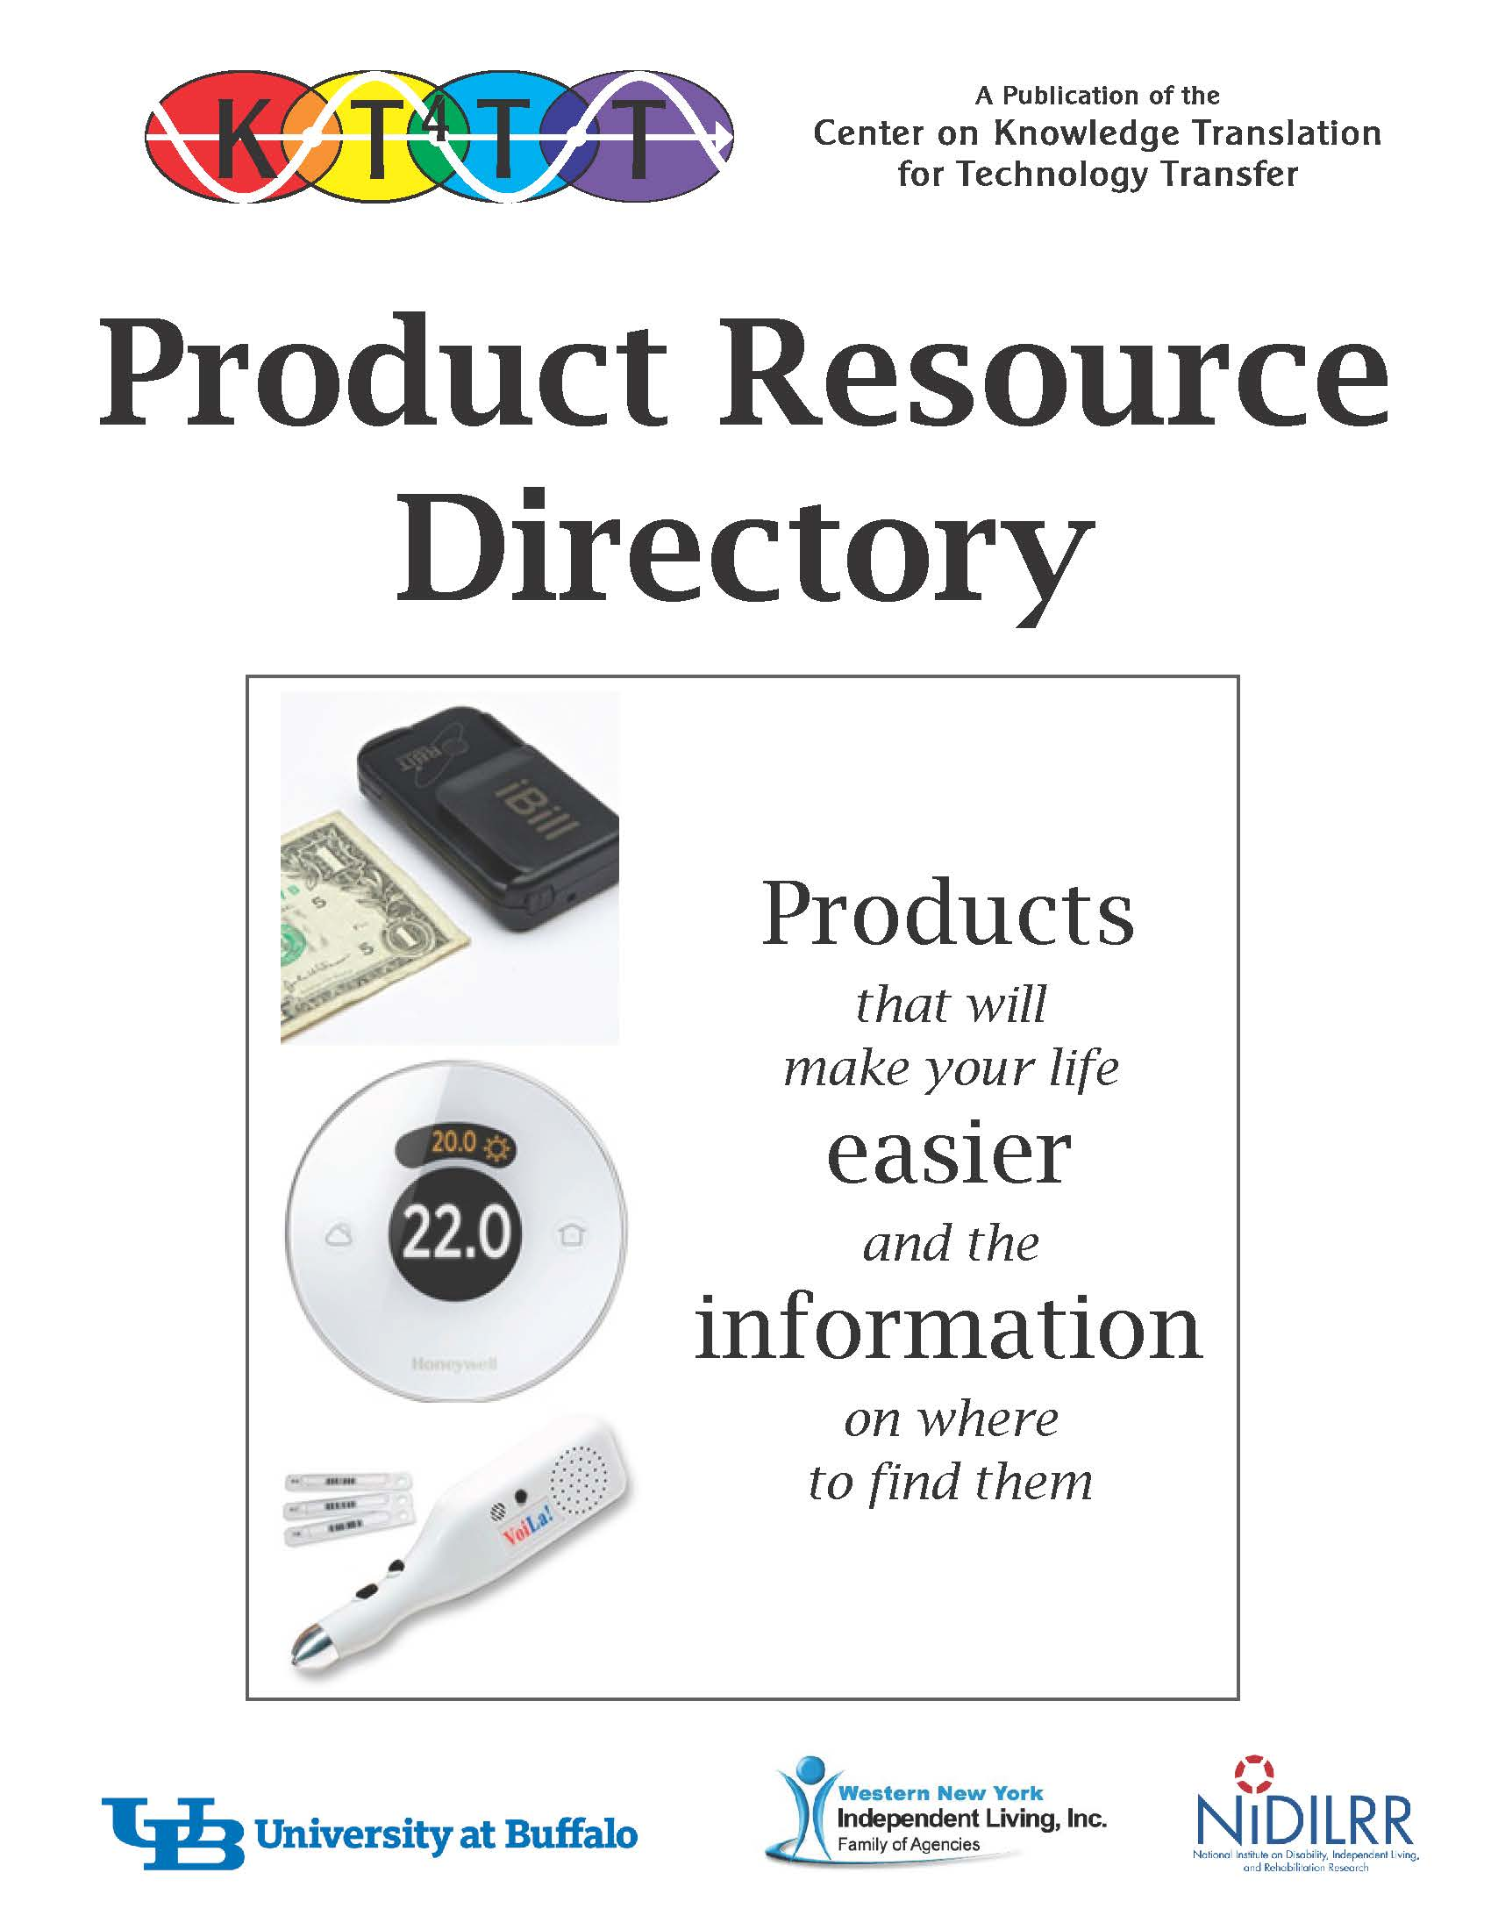

This Product Resource Directory is a representative sample of the myriad of assistive technology and universally designed devices that are available today. This directory aims to provide you with a starting point in your product search, while also providing other avenues to consult in order to receive more information.

Introduction: Many products that seek to aid people in the home, bathroom, kitchen, in recreational pursuits, and in other tasks of daily living are featured in this directory, while many others are also currently available through private retailers.

This directory is arranged according to where the product would be useful, is listed with a description, a picture, the price, and full company contact information. Should you have access to the Internet, you can do a more comprehensive search of products that are available as well as learn more information about the products presented here. If Internet access is not available to you, public libraries usually can provide terminals with this service. An additional resource to consult would be local Durable Medical Equipment (DME) suppliers, such as Sheridan Surgical Incorporated, who can also offer advice on appropriate product catalogues that can be requested and delivered to your home.

Many people struggle with daily tasks simply because they are not aware of products currently available that could assist them. Create a more enjoyable life for yourself by exploring the endless variety of products that are available to make the tasks of daily living easier.

For the Home
Braille Speakerphone with Large Numbers - Designed to assist a myriad of people, this phone features bold 3/4” black numbers, Braille lettering and a variable ringtone. Approximate price is $30.

Features:
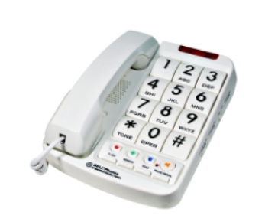
- Bold, raised ¾” numbers
- Braille
- Adjustable ringer
- Volume control
- 13-number memory
- Visual ring indicator
- Speakerphone
- Re-dial & hold buttons

Available from Independent Living Aids, LLC
137 Rano Street
Buffalo, NY 14207
Telephone: 1-800-537-2118
Fax: 516-937-3906
http://www.independentliving.com

TV Partner Universal Remote Control – HUGE remote that can be used with TVs, VCRs, TIVO, DVD and cable boxes. Also enables users to record TV programs. Remote can be hand held or set on a table/chair. Approximate price is $40.

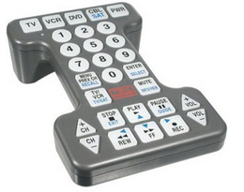
Features:
- Compatible with TVs, VCRs, DVD and cable boxes
- Keys measure ¾” with bold, black numbers
- Measures 8.5” x 5.5” x 2.5” and weights 12 oz
- Numbers light up when a button is pressed

Available from Independent Living Aids, LLC
137 Rano Street
Buffalo, NY 14207
Telephone: 1-800-537-2118
Fax: 516-937-3906
http://www.independentliving.com
Honeywell Smart Thermostat - Voice activated thermostat through the phrase “hello thermostat.” The voice activated thermostat will recognize commands from across the household, or can be controlled remotely by a Smartphone app. It provides hands-free comfort control. Approximate price is $150.
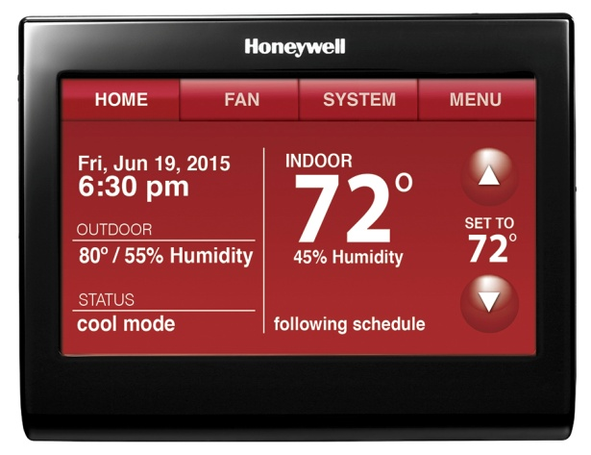
Features:
- Seven day programming
- Flexible programming options
- On-screen comfort information
- Locking touch screen
- Internet time sync
- Indoor humidity sensor
- Advanced fan/control comfort
- Customizable color touch screen

Available from Smarthome Home Automation Superstore
16542 Millikan Avenue
Irvine, CA 92606
Telephone: 1-800-762-7846
Email: custsvc@smarthome.com
http://www.smarthome.com/

Honeywell Lyric Wi-Fi Thermostat – Automatically adjusting thermostat to your activity designed to reduce energy use when sleeping or out of the house. The thermostat considers indoor temperature, indoor humidity and outdoor conditions to perfectly heat your house at all times. Connects with Smartphone or tablet. Approximate price is $200.

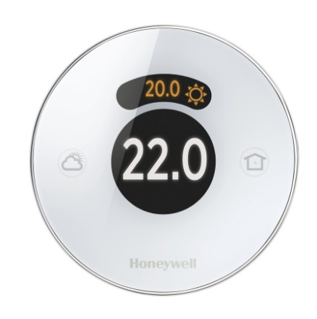
Features:
- Motion sense illumination
- Geofencing: Turn heat up when you are close to being home
- Shortcuts
- Reminders
- Alerts

Available from Smarthome Home Automation Superstore
16542 Millikan Avenue
Irvine, CA 92606
Telephone: 1-800-762-7846
Email: custsvc@smarthome.com
http://www.smarthome.com/
Doorknob Extender –5” extension handle converts a doorknob into a door level providing extra leverage for people with limited hand function. Fits over a standard doorknob and allows complete access to keyholes. Approximate price is $20 for a pack of two.
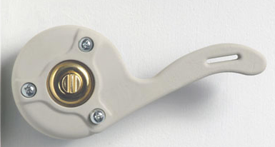

Available from Maddak Inc.
661 Route 23 South
Wayne, NJ 07470
Telephone: 1-800-443-4926
Fax: 973-305-0841
http://www.maddak.com

Moshi Voice Controlled Talking Alarm Clock – Modern styled talking alarm clock that is totally voice controlled. By speaking to the clock, one can retrieve the current time, alarm time, alarm sound, sleep sound and date. Also includes a nightlight and ‘help’ feature. Approximate price is $45.
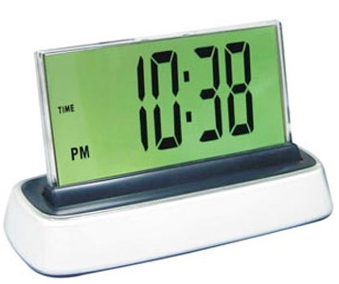

Available from LS&S Products
145 River Rock Drive
Buffalo, NY 14207
Telephone: 1-800-468-4789
Fax: 877-498-1482
www.lssproducts.com

For the Bathroom
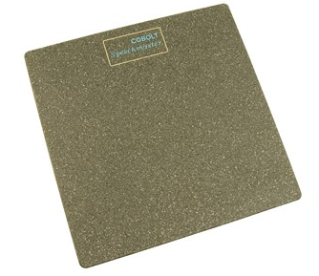
Cobolt Speechmaster Talking Personal Scale – Developed for individuals who strain their eyes to read a normal scale, this anti-slip talking scale tells you your weight in a loud clear voice. Approximate price is $70.

Available from Maxi-Aids
42 Executive Blvd,
Farmingdale, NY 11735
Telephone: 1-800-522-6294
Fax: 1-631-752-0689
https://www.maxiaids.com

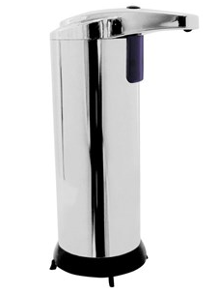
Touch Free Soap Dispenser – Hands free operation with no pressing or squeezing needed. The infrared control dispenses liquid soap with just the wave of your hand. Approximate price is $15.

Available from Maxi-Aids
42 Executive Blvd,
Farmingdale, NY 11735
Telephone: 1-800-522-6294
Fax: 1-631-752-0689
https://www.maxiaids.com

Medical Extra Long Brush – This ergonomically designed brush with anti-slip handle provides maximum reach with minimum effort. It also allows an easy grip for individuals who have trouble gripping their hands. Approximate price is $30.
Available from Maxi-Aids
42 Executive Blvd
Farmingdale, NY 11735
Telephone: 1-800-522-6294
Fax: 1-631-752-0689
https://www.maxiaids.com
Easy Out Tube Squeezer – With a simple pressure from the palm, the easy out tube squeezer gently squeezes from the nozzle of the tube, allowing an individual to get the last drop with ease.
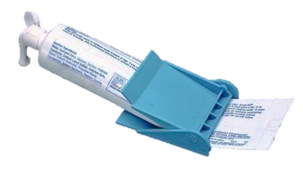
Available from Maddak Inc.
661 Route 23 South
Wayne, NJ 07470
Telephone: 1-800-443-4926
Fax: 973-305-0841
http://www.maddak.com

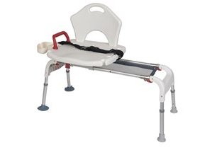
Folding Universal Sliding Transfer Bench – For easy entry into and exist out of bathtub. Transfer bench slides left and right along frame. Includes a seat belt for added safety, and safety net to catch dropped items and prevent bending in the bathtub. Approximate price is $150.

Available from Maxi-Aids
42 Executive Blvd
Farmingdale, NY 11735
Telephone: 1-800-522-6294
Fax: 1-631-752-0689
https://www.maxiaids.com

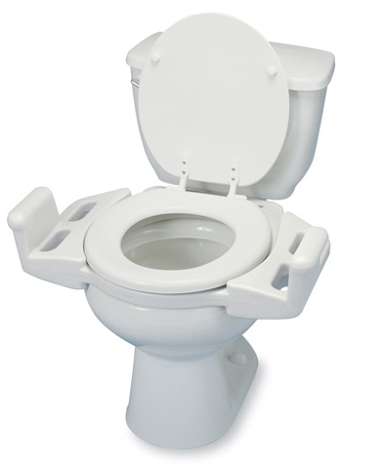
Push-up Elevated Toilet Seat – Converts a standard toilet seat into an elevated seat with armrests that are optimally designed to assist a person lower to or push up from the toilet. Approximate price is $100.

Available from Maddak Inc.
661 Route 23 South
Wayne, NJ 07470
Telephone: 1-800-443-4926
Fax: 973-305-0841
http://www.maddak.com
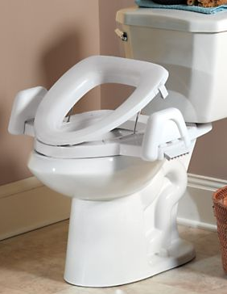
EZ Boost Toilet Seat – Tilting toilet seat that gently lowers and lifts you in a natural body motion using spring compression. Non –slip padded, side grippers keep you balanced as you sit and stand. Approximate price $180.

Available from Gold Violin
100 Murray Drive
Warren, PA 16368
Telephone: 1-877-648-8466
http://goldviolin.blair.com

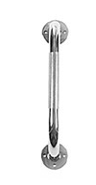
Chrome Grab Bar – Designed to give added security in and around the bathroom. Mounts in a variety of angles to wall structure supports that protect the wall surface. Approximate price ranges from $20 to $20 each depending on the length/width of the bar.

Available from Maxi-Aids
42 Executive Blvd
Farmingdale, NY 11735
Telephone: 1-800-522-6294
https://www.maxiaids.com

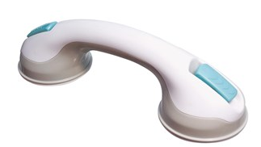
Assist Suction Tub Bar – Designed to help individuals get in and out of both the shower and tub. This bar conveniently attaches to the tub or shower wall for better balance. Not meant to be used as body weight leverage. Easy attachment makes it great for traveling. Approximate price is $25.

Available from Maxi-Aids
42 Executive Blvd
Farmingdale, NY 11735
Telephone: 1-800-522-6294
https://www.maxiaids.com

For the Kitchen
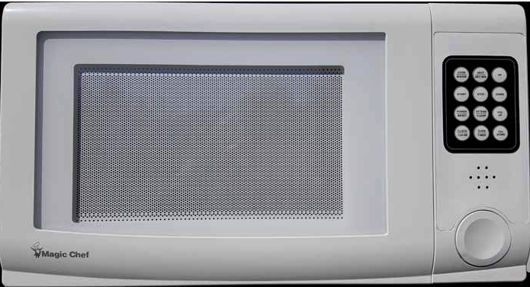
Talking Microwave – Magic Chef Microwave that has been modified to talk to users with low vision. Approximate price is $370.
Features:
- Prompts to stir/turn food
- Announce cook time left
- Announce when door is open
- Announce current time
- Labeled touch pad
- 24 hour timer
Available from LS&S Products
145 River Rock Drive
Buffalo, NY 14207
Telephone: 1-800-468-4789
Fax: 877-498-1482
www.lssproducts.com

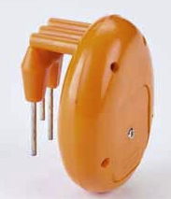
Vibrating Liquid Level Indicator – Small sized liquid level indicator that buzzes and vibrates when liquid nears the top of a glass. Detects 2 different liquid levels in the glass and makes an intermittent noise as the liquid nears the top and continuous tone once it reaches the top. Approximate price is $15.

Available from LS&S Products
145 River Rock Drive
Buffalo, NY 14207
Telephone: 1-800-468-4789
Fax: 877-498-1482
www.lssproducts.com

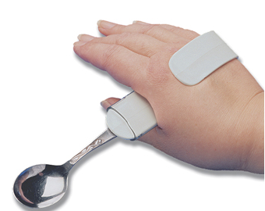
Utensil Hand Clip – Eating aid for people who have trouble grasping and holding small utensils. Slide the utensil into the small plastic sleeve, the spring action clip then fits the hand. Approximate price is $10.

Available from LS&S Products
145 River Rock Drive
Buffalo, NY 14207
Telephone: 1-800-468-4789
Fax: 877-498-1482
www.lssproducts.com

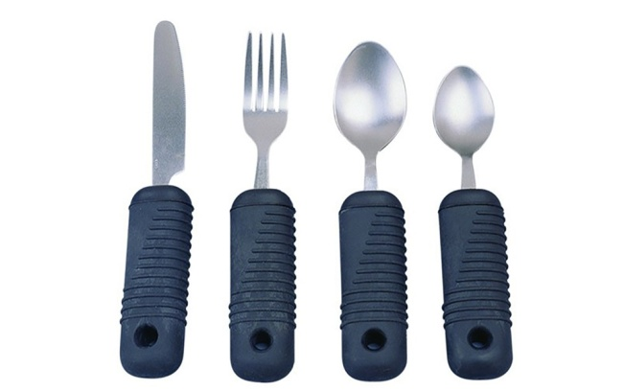
SuperGrip Utensils – Specially designed eating utensils that contain oversized rubber handles for those with minimal hand or wrist strength. In addition, the shafts of the handles are bendable in order to make their use easier for those with limited motion capabilities. Approximate price is about $10 per utensil.

Available from Maxi-Aids
42 Executive Blvd
Farmingdale, NY 11735
Telephone: 1-800-522-6294
Fax: 1-631-752-0689
https://www.maxiaids.com

Easy Touch Can Opener – Designed to easily open cans. Place the opener on the can, press the button and the Easy Touch opens the can on its own. Approximate price is $20.
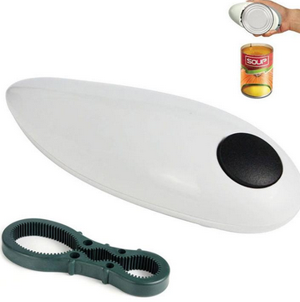

Available from LS&S Products
145 River Rock Drive
Buffalo, NY 14207
Telephone: 1-800-468-4789
Fax: 877-498-1482
www.lssproducts.com
Jumbo Timer – ¼” digits for easy display. This timer can count up or down and can both stand or hang with a magnet. Approximate price is $13.
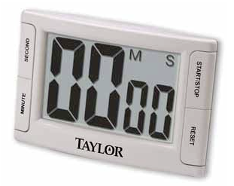

Available from LS&S Products
145 River Rock Drive
Buffalo, NY 14207
Telephone: 1-800-468-4789
Fax: 877-498-1482
www.lssproducts.com

Select-A-Spice Carousel – Spice organizer that measures out ¼ teaspoon with each click. Includes 12 canisters on a rotating base and 55 spice labels. Approximate price is $30.

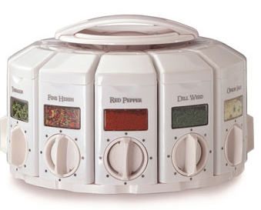

Available from LS&S Products
145 River Rock Drive
Buffalo, NY 14207
Telephone: 1-800-468-4789
Fax: 877-498-1482
www.lssproducts.com

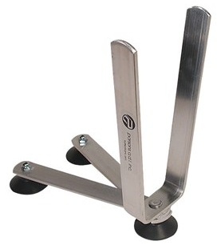
Folding Pot Stabilizer – Holds onto the pot handle while you stir the contents. Folds up when not in use. Approximate price is $30.

Available from Maxi-Aids
42 Executive Blvd
Farmingdale, NY 11735
Telephone: 1-800-522-6294
Fax: 1-631-752-0689
https://www.maxiaids.com

Safe Slice Knife Guard – Kitchen tool with soft flexible thermoplastic fingertip grips that provides a firm grip on food and flexes naturally with finger movement. Has a hard plastic shield that protects fingers as you slice and dice. Approximate price is $5.
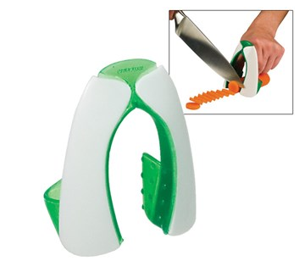

Available from Maxi-Aids
42 Executive Blvd
Farmingdale, NY 11735
Telephone: 1-800-522-6294
Fax: 1-631-752-0689
https://www.maxiaids.com

One-Way Straws – These 10” straws feature one-way valves, which allows the straws to remain filled with liquid at all times. This reduces the amount of effort needed to operate them effectively. Approximate price is $20 for a pack of 5 straws.

Available from Patterson Medical
28100 Torch Parkway, Suite 700
Warrenville, IL 60555
Telephone: 630-393-6000
Email: sp@pattersonmedical.com
www.pattersonmedical.com

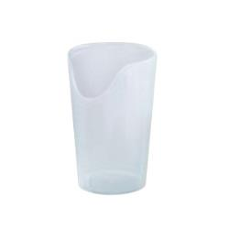
Nosey Cutout Glass – These glasses are specially designed with an opening for your nose, which prevent unnecessary head and neck movement when drinking. Approximately price $7 for one 8 oz tumbler and $8 for one 12 oz.

Available from Patterson Medical
28100 Torch Parkway, Suite 700
Warrenville, IL 60555
Telephone: 630-393-6000
Email: sp@pattersonmedical.com
www.pattersonmedical.com

Accessories
House and Car Key Holders – These holders can carry up to four keys in a plastic or acrylic frame. They make gripping and turning a small individual key easier due to their increased size and ergonomic shape. Approximate price is $15.
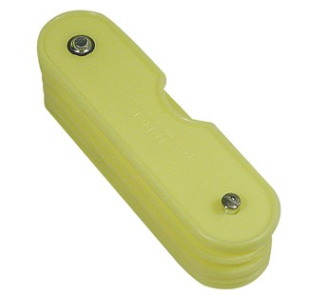

Available from Maxi-Aids
42 Executive Blvd
Farmingdale, NY 11735
Telephone: 1-800-522-6294
Fax: 1-631-752-0689
https://www.maxiaids.com

Big Button Talking Calculator – This big button talking calculator allows you to go back and listen to the data functions. Easy to use with color coded buttons, this calculator is easy to see and hear for both hard of hearing and low vision users. Approximate price is $15.
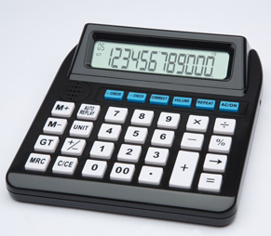
Features:
- Repeat allows you to listen to most recent entry
- Auto replay for the whole function
- 3 volume settings
- Earphone jack
- Unit or digit reporting

Available from LS&S Products
145 River Rock Drive
Buffalo, NY 14207
Telephone: 1-800-468-4789
Fax: 877-498-1482
www.lssproducts.com

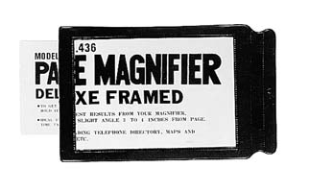
Page Magnifier – This page magnifier offers 1.5x magnification for use on maps, timetables, telephone directories and more. This magnifier measures 6 inches x 8.5 inches with a black vinyl frame and is great for low vision users. Approximate price is $2 each.

Available from LS&S Products
145 River Rock Drive
Buffalo, NY 14207
Telephone: 1-800-468-4789
Fax: 877-498-1482
www.lssproducts.com

iBill Talking Banknote Identifier – Discrete bill identifier that can identify all U.S. bills in circulation from $1 to $100. The results can be announced verbally, by tone, or by vibration, making the product perfect for those of low vision or hearing. The product also features an earphone jack for privacy. Available free of charge from the Bureau of Engraving and Printing.
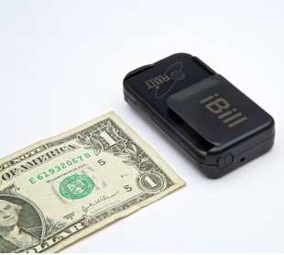

Available from Bureau of Engraving and Printing
14th and C Streets
Washington, D.C. 20228
Telephone: 1-844-815-9388
www.bep.gov

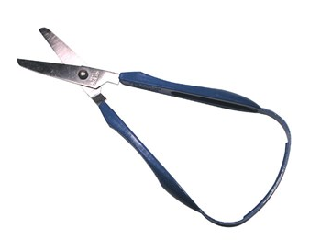
Easi-Grip Scissors – Designed for those that have difficulties operating scissors, the Easi-Grip Spring Scissors require only half the effort of normal scissors. Operated by squeezing gently using thumb and fingers, the continuous plastic handled automatically reopens the scissor when pressure is released. Approximate price is $15.

Available from Maxi-Aids
42 Executive Blvd
Farmingdale, NY 11735
Telephone: 1-800-522-6294
Fax: 1-631-752-0689
https://www.maxiaids.com

VoiLa Voiced Label Reader – This portable, handheld device with only two buttons is capable of reading and recording hundreds of labels. The VoiLa works on all labels from food products to medicine. Available in multiple languages. Approximate price is $140.
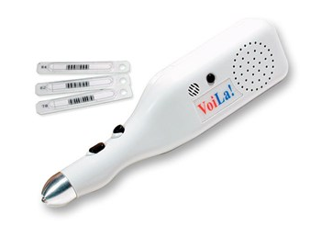

Available from Maxi-Aids
42 Executive Blvd
Farmingdale, NY 11735
Telephone: 1-800-522-6294
Fax: 1-631-752-0689
https://www.maxiaids.com

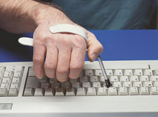
Type Aid – This device helps people with limited function hand skills to accurately depress keys. Can be used on keyboards, calculators and telephones; will not damage machine keys. Approximate price is $20.

Available from Maddak Inc.
661 Route 23 South
Wayne, NJ 07470
Telephone: 1-800-443-4926
Fax: 973-305-0841
http://www.maddak.com
Med-e-lert Automatic Pill Dispenser – Helps to ensure that medications are taken properly and on time. Schedule up to 6 daily doses with the built-in programmable timer. This easy to use medication management system will dispense the right dosage of the right pills at the right time. Approximate price is $75.
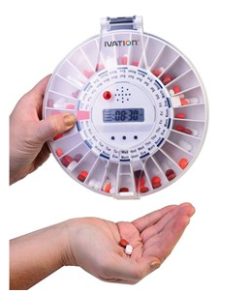
Features:
- Audible and visual signals at dose time
- Up to 6 alarms
- Holds doses for up to two weeks
- Secured locking system
- Interchangeable solid and clear covers
- Low battery alert

Available from Maxi-Aids
42 Executive Blvd
Farmingdale, NY 11735
Telephone: 1-800-522-6294
Fax: 1-631-752-0689
https://www.maxiaids.com

Talking Rx – Helps patients identify their medications and understand physician directions for taking them properly. The device attaches to a common-sized prescription bottle and contains a memo recorder that allows a physician, pharmacist, caregiver, etc. to record necessary information about the medication. Approximate price is $25.

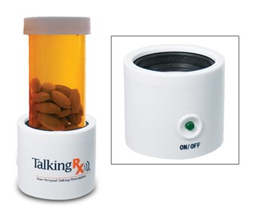

Available from Maxi-Aids
42 Executive Blvd
Farmingdale, NY 11735
Telephone: 1-800-522-6294
Fax: 1-631-752-0689
https://www.maxiaids.com

Object Locator – Helps keep track of items that like to wander. By attaching the color coded received to an item, you can press the corresponding button and the transmitter pager will emit a high pitched beeping pattern. Approximate price is $20 for a set of 3.
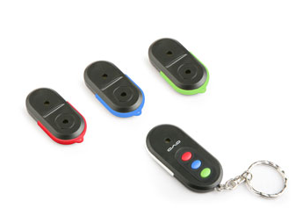

Available from LS&S Products
145 River Rock Drive
Buffalo, NY 14207
Telephone: 1-800-468-4789
Fax: 877-498-1482
www.lssproducts.com

Colorino Color Identifier – Color identifier that can distinguish and announce over 150 different shades, getting as specific as light red and vivid red. It is very accurate and easy to use, making it perfect for people with low vision to pick out clothes, sort laundry, match colors, etc. Approximate price is $180.
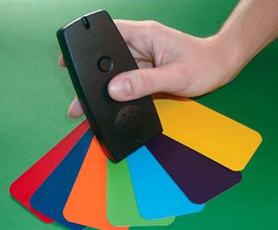

Available from LS&S Products
145 River Rock Drive
Buffalo, NY 14207
Telephone: 1-800-468-4789
Fax: 877-498-1482
www.lssproducts.com

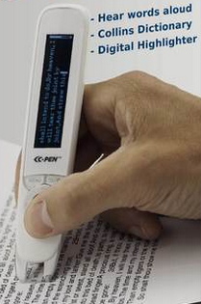
Reader Pen – Stand alone digital pen designed to help individuals read. Available in English and Spanish this device has four main features: (1) text reading using a high quality natural speaking voice, (2) a Collins English dictionary, (3) an English/Spanish Oxford dictionary and (4) capturing text remotely to file or directly to a cursor point on any computer. To use, one simply scans words to hear them spoken aloud. Current price is $250.

Available from C-Pen
Telephone: 727-316-8101
Fax: 617-341-8201
www.readerpen.com

WEAR: Revolutionary Assistive Listening Device – Product that is designed to be used when an individual who is experiencing hearing loss wants a quality conversation in very noisy environmental. The WEAR amplifies sound directly in the circular zone, about 5-6 feet in front of the user, while reducing noise outside of the zone. Current price is $200.
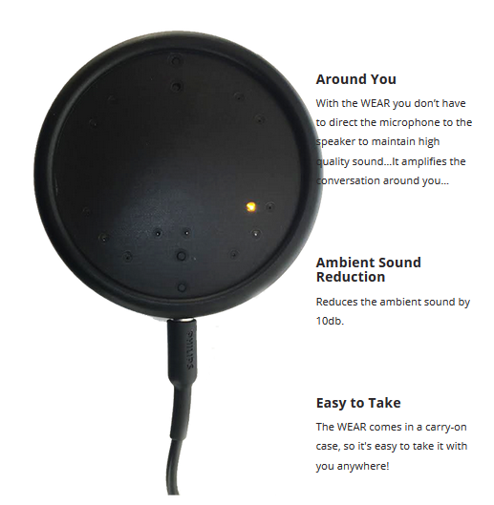

Available from ActiVocal
290 Andrews Road
Feasterville-Trevose, PA 19053
Telephone: 888-246-5984
Email: info@activocal.com
www.activocal.com

Mobility
Easy Get Up Support Rail – Get in and out of chairs, couches and beds easily. Sturdy ladder design provides maximum support and allows you to use both hands for leverage. Enables you to safely get in and out of chairs without assistance from another person. Approximate price is $50.
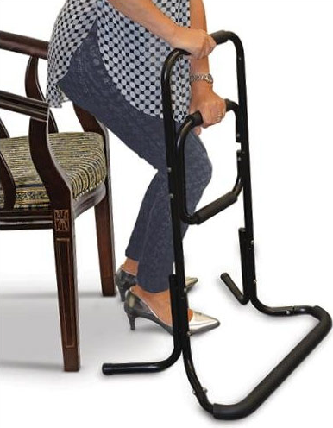
Features:
- Durable, steel frame
- Wide, sturdy base to reinforce stability
- Ergonomic foam grips

Available from Maxi-Aids
42 Executive Blvd,
Farmingdale, NY 11735
Telephone: 1-800-522-6294
Fax: 1-631-752-0689
https://www.maxiaids.com

Leg Lift – This is a simple, yet practical device used for people with limited lower extremity strength, enabling them to lift their foot onto a wheelchair foot rest, bed or car. Approximate price is $12.
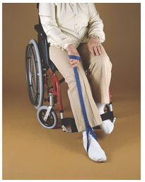

Available from Maddak Inc.
661 Route 23 South
Wayne, NJ 07470
Telephone: 1-800-443-4926
Fax: 973-305-0841
http://www.maddak.com

Adjustable Telescoping Wheelchair Ramp – Designed to contract for storage in a nylon carrying bag, which hangs over wheelchair handles, this wheelchair ramp easily extends for universal use with steps, curbs or vehicles. Approximate price is $125.
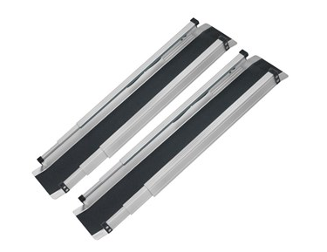
Features
- Completely adjustable
- Push-button locking mechanism
- U-shaped, rust resistant
- Non-skid treads
- 660lb weight capacity
Available from Maxi-Aids
42 Executive Blvd,
Farmingdale, NY 11735
Telephone: 1-800-522-6294
Fax: 1-631-752-0689
https://www.maxiaids.com

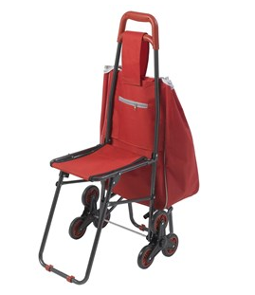
Deluxe Rolling Shopping Cart with Seat – Handy wheeling bag to help assist in the carrying of groceries, laundry, etc. Its tri-wheel design allows you to effortlessly roll up stairs and over curbs. Product includes a unique flip down seat which provides a comfortable place to rest when you’re out and about. Approximate price is $50.

Available from Maxi-Aids
42 Executive Blvd,
Farmingdale, NY 11735
Telephone: 1-800-522-6294
Fax: 1-631-752-0689
https://www.maxiaids.com

Car Cane – This product slips into the latch of a car door for a firm gripping handle to assist individuals in getting out of the car. The nonslip grip is comfortable to hold and provides great leverage to push down upon and lift oneself out of the car seat. Supports up to 350 lbs. Also used to provide a supportive grip that can help one from slipping or sliding during poor weather. Includes a built in flashlight. Approximate price is $20.
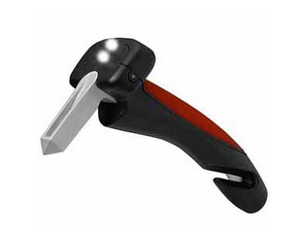

Available from Independent Living Aids, LLC
137 Rano Street
Buffalo, NY 14207
Telephone: 1-800-537-2118
Fax: 516-937-3906
http://www.independentliving.com

Handhold – This product is useful for anyone who may experience decreased stability. Gripping the handhold with one hand allows one to become more stable resulting in increased coordination to perform daily activities such as eating, reading, writing, etc. The product can be suctioned to any smooth, hard surface. Approximate price is $40
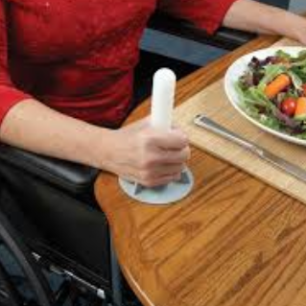

Available from Maddak Inc.
661 Route 23 South
Wayne, NJ 07470
Telephone: 1-800-443-4926
Fax: 973-305-0841
http://www.maddak.com

Recreation
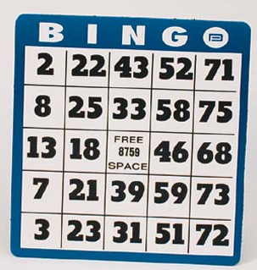
Low Vision Bingo Card – This bingo card is made out of heavy duty material, brightly colored with with large print, making it great for people who have trouble finding numbers. Approximate price is $2.

Available from LS&S Products
145 River Rock Drive
Buffalo, NY 14207
Telephone: 1-800-468-4789
Fax: 877-498-1482
www.lssproducts.com

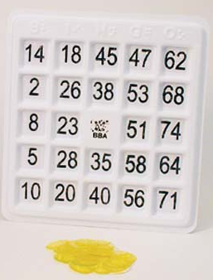
Braille Bingo Card – This bingo card features both raised numbers and Braille markings. Complete with large indented number slots to accommodate yellow markers are ideally set up so that the markers stay in place. Approximate price is $10.

Available from LS&S Products
145 River Rock Drive
Buffalo, NY 14207
Telephone: 1-800-468-4789
Fax: 877-498-1482
www.lssproducts.com

EZC Playing Cards – Large 1.25 inch numbers are easily read by visually impaired individuals. Cards have high contrast white letters on dark backgrounds for hears and diamonds, and black backgrounds for clubs and spades complete with an easy to identify code for quick suit recognition. Approximate price is $5.
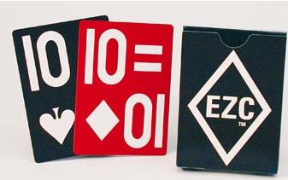
Available from LS&S Products
145 River Rock Drive
Buffalo, NY 14207
Telephone: 1-800-468-4789
Fax: 877-498-1482
www.lssproducts.com

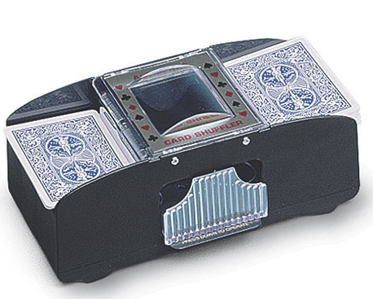
Battery Powered Card Shuffler – Capable of shuffling two decks at once, this device eliminates the need to shuffle cards by hand, a task sometimes difficult due to arthritis or limited use of hands. Approximate price is $30.

Available from Maddak Inc.
661 Route 23 South
Wayne, NJ 07470
Telephone: 1-800-443-4926
Fax: 973-305-0841
http://www.maddak.com

Playing Card Holder – This plastic device stands upright on any table, and is capable of holding an entire hand of cards, eliminated the need to hold cards individually. Designed for those with arthritis, limited hand strength, or those simply wanting to rest their hands, this device is clear for greater visibility. Approximate price is $8.
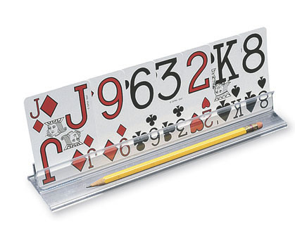
Available from Maddak Inc.
661 Route 23 South
Wayne, NJ 07470
Telephone: 1-800-443-4926
Fax: 973-305-0841
http://www.maddak.com
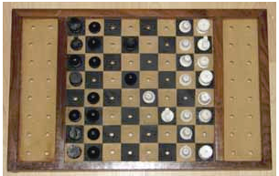
Tactile Chess – Chess set designed specifically for the blind and visually impaired. The board is completely tactile, including pegs on each plastic playing piece and holes in the wooden chess board to hold each piece in place within the square. Each plastic piece is shaped differently, white pieces have a bump on top and the dark squared on the board are raised to help track board colors. Approximate price is $30.

Available from LS&S Products
145 River Rock Drive
Buffalo, NY 14207
Telephone: 1-800-468-4789
Fax: 877-498-1482
www.lssproducts.com

Visually Impaired Yoga Mat – This yoga mat is designed in three dimensions with raised and depressed ‘stations’ strategically placed to help the individual feel where hands, feet, head, spine or stomach should be placed during a yoga sequence. The markings include a raised center line, two sets of feet stations and three set of hand stations with Braille labels. Also comes with 2 instructional videos. Approximate price is $75.

Available from LS&S Products
145 River Rock Drive
Buffalo, NY 14207
Telephone: 1-800-468-4789
Fax: 877-498-1482
www.lssproducts.com

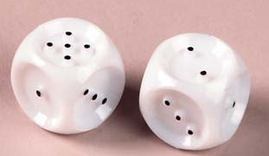
Braille Dice – Braille dice designed for blind and visually impaired individuals to use with any game. Approximate price is $3.

Available from LS&S Products
145 River Rock Drive
Buffalo, NY 14207
Telephone: 1-800-468-4789
Fax: 877-498-1482
www.lssproducts.com

Double Six Dominos: Raised Dots - 28 piece set of dominos with raised dots, perfect for blind and visually impaired individuals. Approximate price is $12.
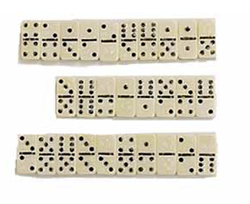

Available from LS&S Products
145 River Rock Drive
Buffalo, NY 14207
Telephone: 1-800-468-4789
Fax: 877-498-1482
www.lssproducts.com

Beeping Foam Ball – When activated, this battery-operated ball produces a high pitched beeping noise that allows those with impaired vision to throw and catch it. Approximate price is $35.

Available from Maxi-Aids
42 Executive Blvd
Farmingdale, NY 11735
Telephone: 1-800-522-6294
Fax: 1-631-752-0689
https://www.maxiaids.com

Additional Resources
https://www.ncoa.org/ National Council on the Aging

https://www.nia.nih.gov/ National Institute on Aging

http://abledata.com/ Abledata, your source for assistive technology information

http://www.leadingage.org/ LeadingAge

Sheridan Surgical Inc.
4513 Bailey Ave
Buffalo, NY 14224
716-836-8780
http://www.sheridansurgical.com/

Complete Home Care
60 Broad Street
Tonawanda, NY 14150
716-694-2554
http://completehomecare.com/

Bensons Surgical Supply
2776 Delaware Ave
Kenmore, NY 14217
716-332-0404
http://www.bensonsurgical.com/

Center for Assistive Technology, Inc. (Erie, Genesee, Niagara, Orleans, Wyoming) – TRAID Program
315 Alberta Drive, Suite 102
Amherst, NY 14226
Voice: (716) 836-1350
Voice/TTY 800-628-2281
Website: www.cat.buffalo.edu/traid
Contacts: Tina Oddo oddo@buffalo.edu
Kim Naus ksnaus@buffalo.edu

Assistive Technology (TRAID) Program
Through a federal grant from the US Department of Health and Human Services Administration for Community Living (ACL), the Justice Center administers the Technology-Related Assistance for Individuals with Disabilities (TRAID) Program. The TRAID Program’s mission is to coordinate statewide activities to increase access to and acquisition of assistive technology in the areas of education, employment, community living and information technology/telecommunications.

The Justice Center supports 12 Regional TRAID Centers (RTCs) which provide information, training, device demonstration, reuse, exchange, and loans. In addition it provides technical assistance and advocacy on how to obtain and use assistive technology services and devices. A list of the centers located statewide can be found at https://www.justicecenter.ny.gov/services-supports/assistive-technology-traid/locations.

The Justice Center also participates in a multi-state online equipment exchange collaborative. Items can be found at lower than market price or for no cost on its website at www.getATstuff.com.

